Assignment Data Visualization

vinitas@justit.co.uk

Contents
Assignment Requirements 2
First Task 3
Policies and Procedures 3
Second task 3-14
Excel 3
The data 3
Third Task 4
Tableau 14-20
A reflective learning log ………………………………………………………………………………………………..20-21

First task. Policies and procedures

There are several laws governing use of information with data and computer misuse policies. These laws protect users and their data from attack and misuse.
For that reason, to be working with data, we need to take into account The computer Misuse Act 1990 to understand the unauthorized access or modification to computer material, created to deal with the issue of accessing or modifying data without permission.
Also DGPR The General Data Protection Regulation, created in 2018 based on the ethical use of personal data and keeping every individual’s personal data secure. This law is essential to take into account in the data sector working with data. This law controls how organizations, businesses and the government controls personal information. It is important to comply with this law working with data. The information we are working with needs to obtain permission from the customers for us to be able to use their data in line with GDPR procedure regulations to store and process the data in order to follow the data protection Act 2018.

Second task. GDP tasks
- Working with GDP (Gross Domestic Product). for the excel work ‘The Wealth of nation data’.
In order to follow The computer Misuse Act 1990 to help us to understand better the importance of the security when it comes to work within Information Technology industry, we have going through how to protect a worksheet enclosed with a password as it is required to fulfill with the Data Protection Act 2018 to handle in a secure way, including protection against unlawful.

GDP Tasks
- Set a password to protect the worksheet: in the yellow circle I click to protect the workbook.
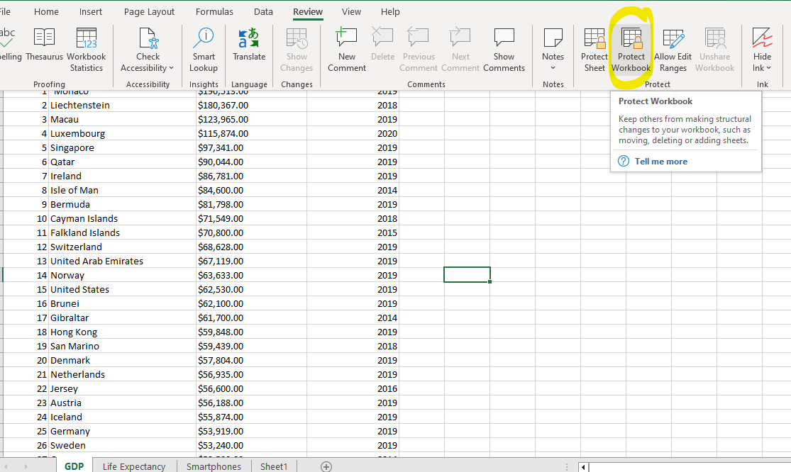
Then I add a password.
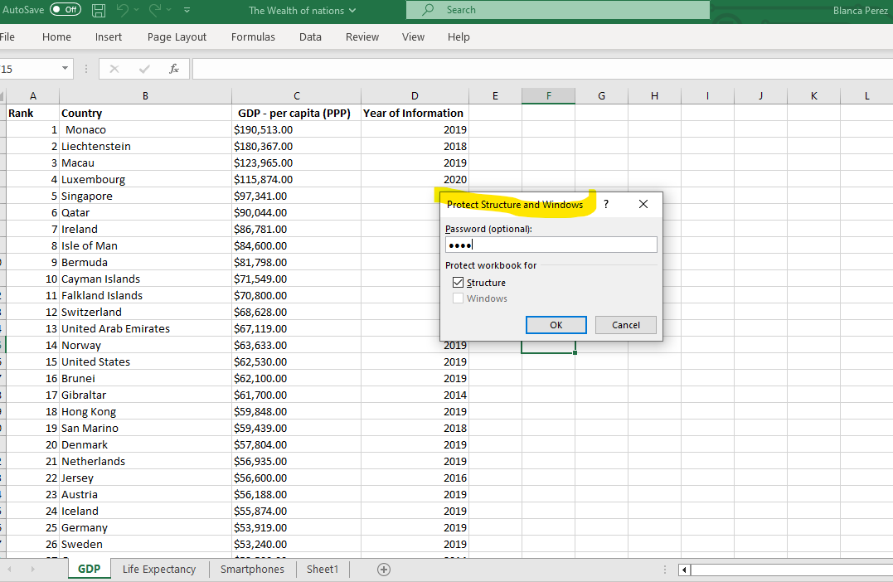

- Highlight column C and change the data to display in British Pound symbol.
First I highlight column and then I fill it in with the color selected. I add the
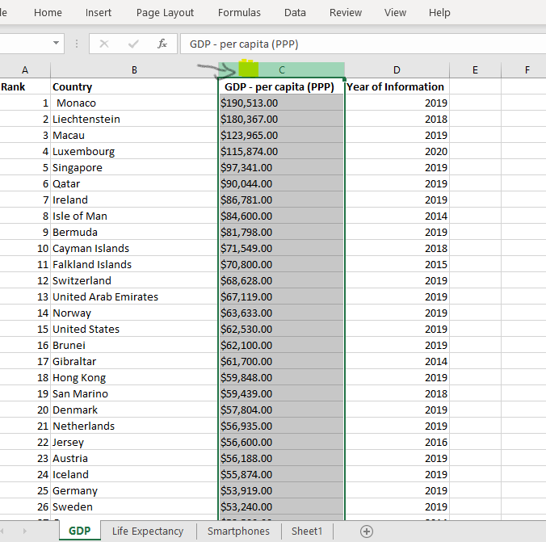
Then I add the pounds symbol in data>currency.
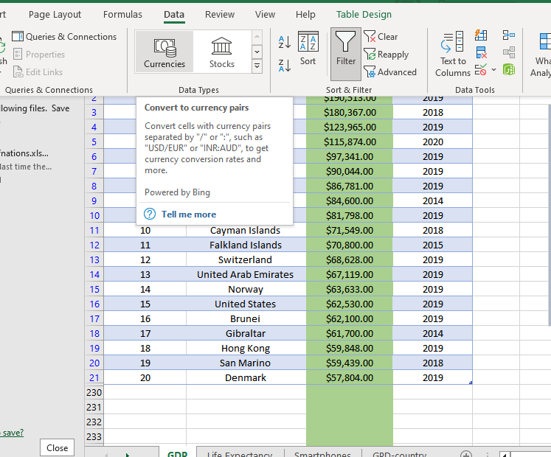

- Turn the GDP sheet into a table
First I select the content of the GDP sheet, scroll down to select all the information. Then I select insert > create a table and press ok.

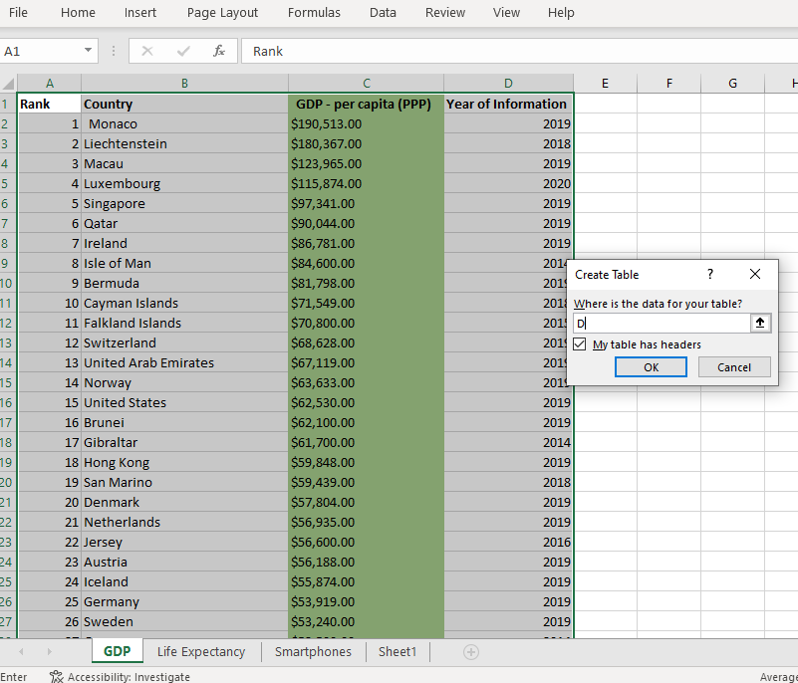
And it will look like this picture:
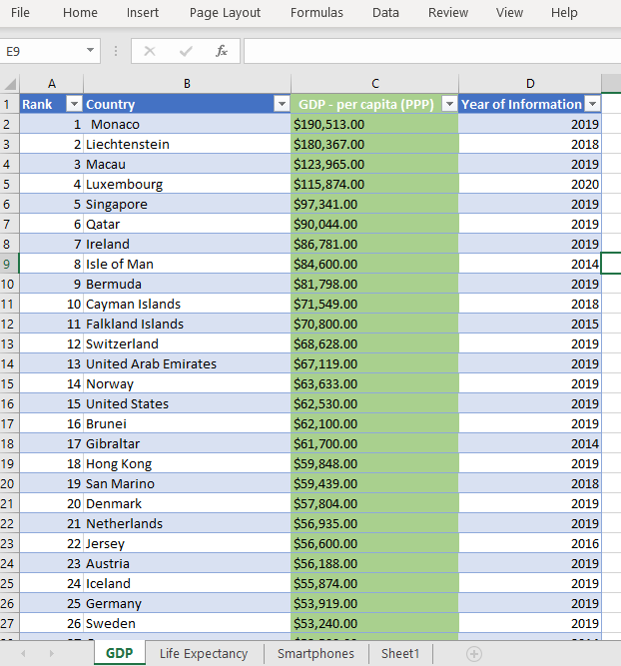

- Filter the table to display only the information for 2019.
In 2019 year information arrow, I select only 2019 and deselect the rest of the years, then click ok.

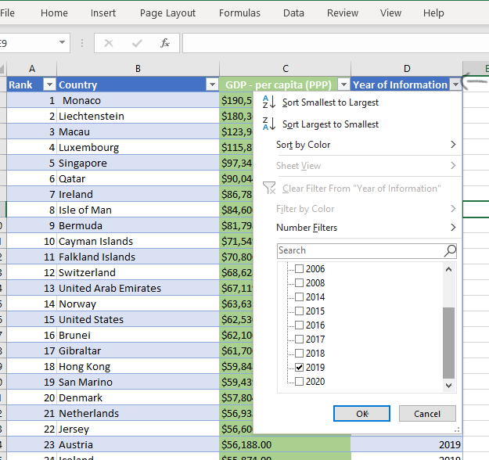

- Create a chart to display the data: rank, country and GDP – per capita (PPP).
First I insert a chart, the most appropriate according to the data I want to show.
I have pressed insert > recommend charts > all charts and here excel has suggested me the most recommendable for my data. I have choice clustered column.
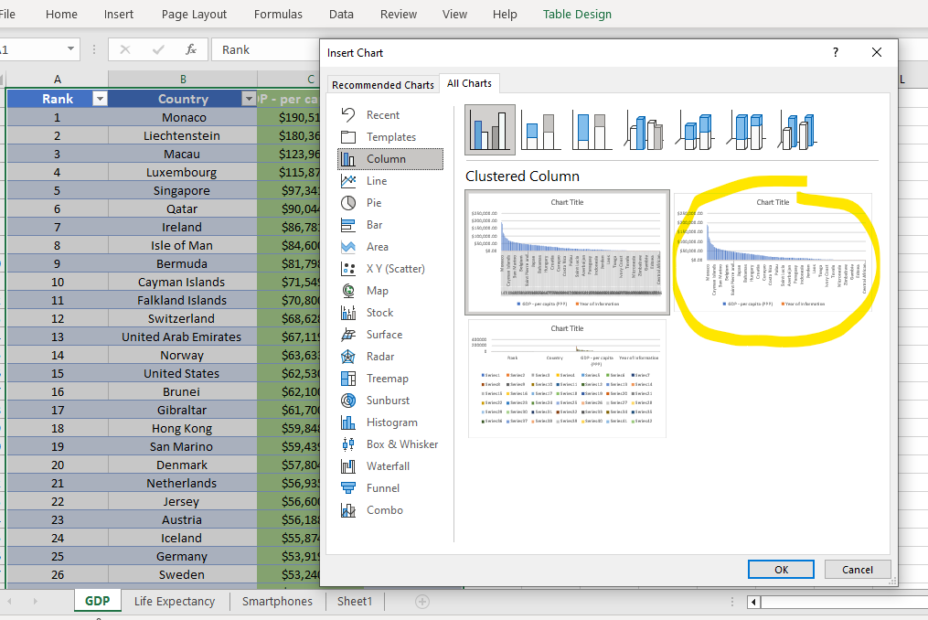

- Edit the chart
- Add a tittle
- Add x and y axis labels
- Make the chart visually pleasing
Change the title, add x and axis and makes it looks more visual adding color.

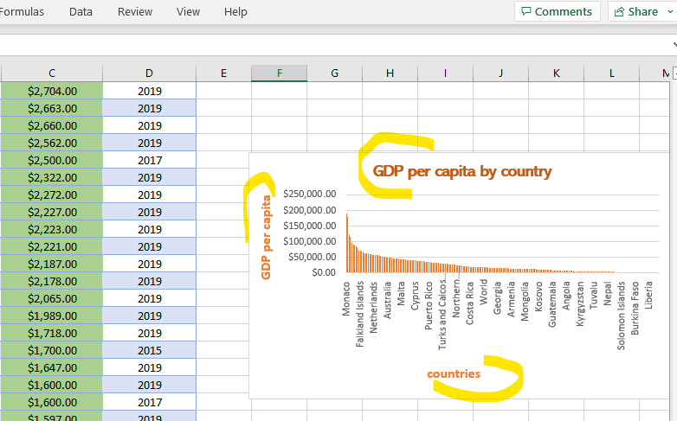
- Move the chart to a new sheet tab and label

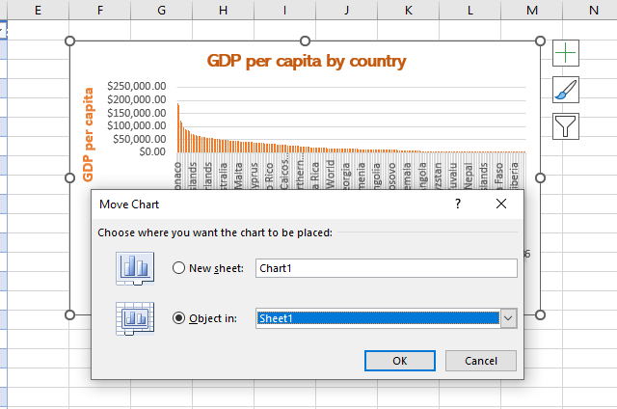

Now has changed the label of the sheet to GPD-country
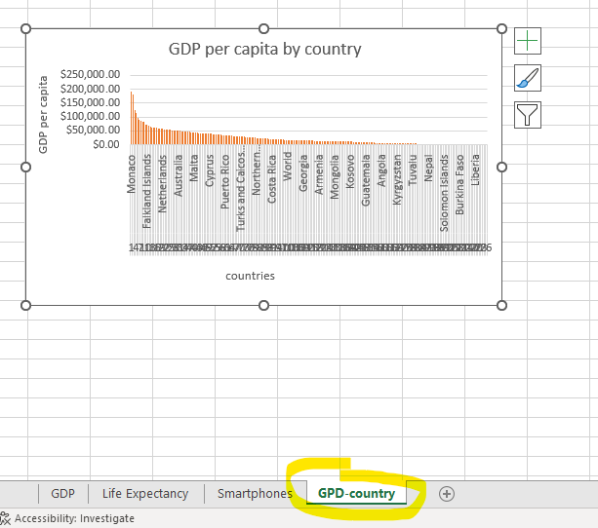

- Select top 20 from the bottom and comes already organized with Monaco with the highest …
I press ranking, the number of filters and I change it to 20 countries. I click show and I select the bottom countries to classify the top 20 by renta per capita.
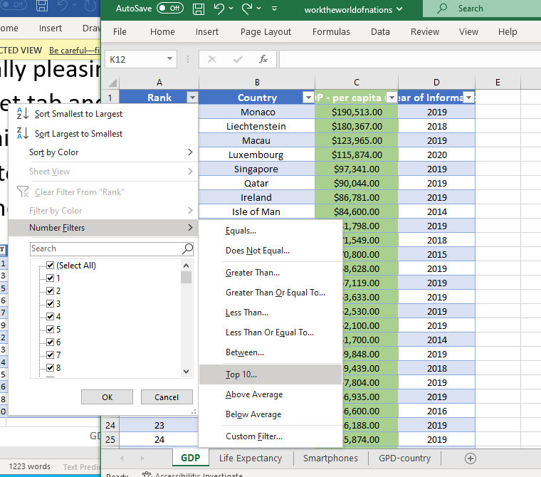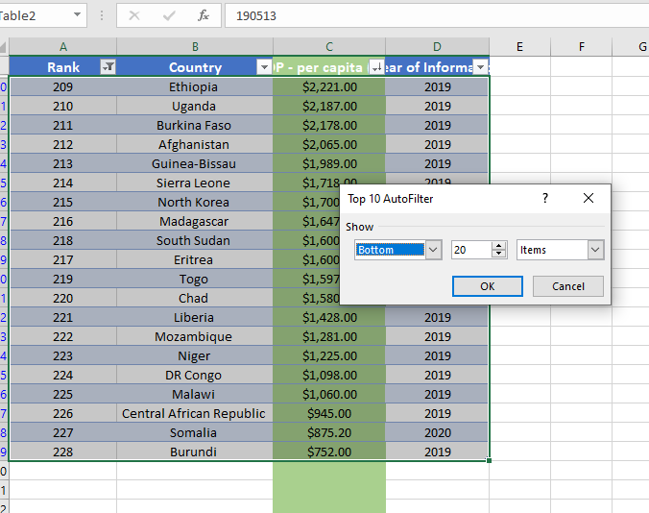

- Create a new Bar chart to display the 20 highest ranking countries from your sort and then move the chart to be underneath the table.
I press insert chart > recommendable and I select the stacked chart.

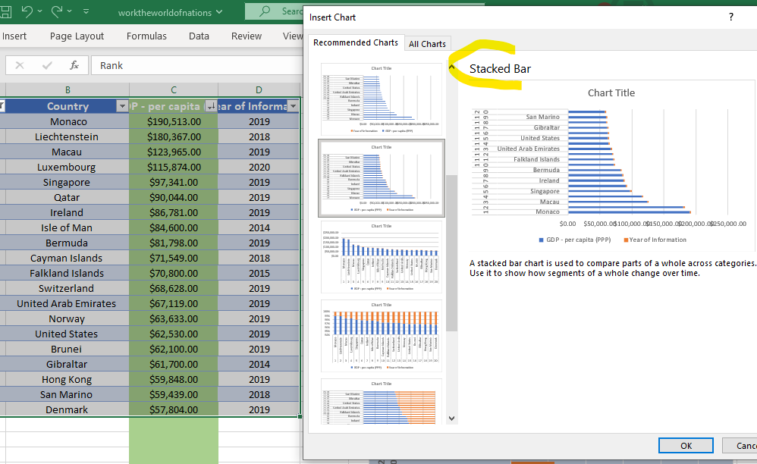

Press insert chart Add a colour to the background of the table by clicking two times on the chart. Add a format to the table.
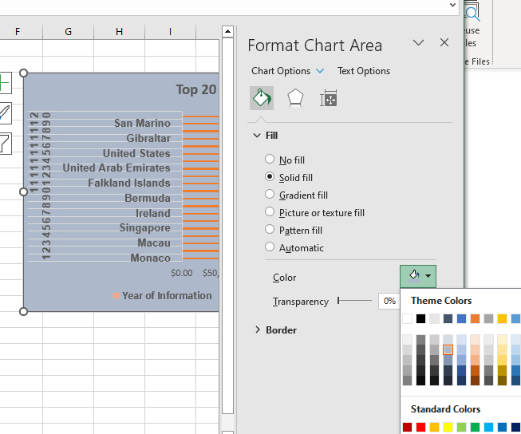

The chart as shown below is located underneath the table.
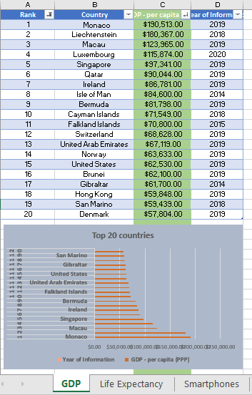

- Create 3 macro buttons, print the sheet.
To create the macros, first I go to view > macros. The first thing I do is record macros. I select a macro name, add a shortcut and a description. I save this macro as Macro name: print, I store it in personal macro workbook and I add a description: print sheet.

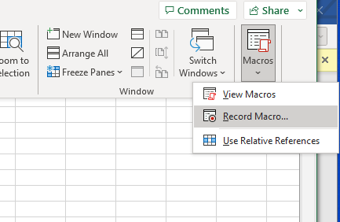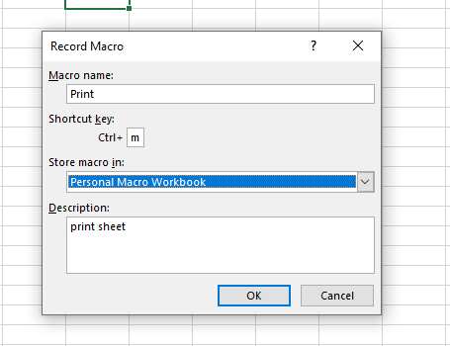

So now it is already recording any action that I take. I go over to save the excelsheet as file > save as enable workbook. In the meantime I take this action, the macros still recording.
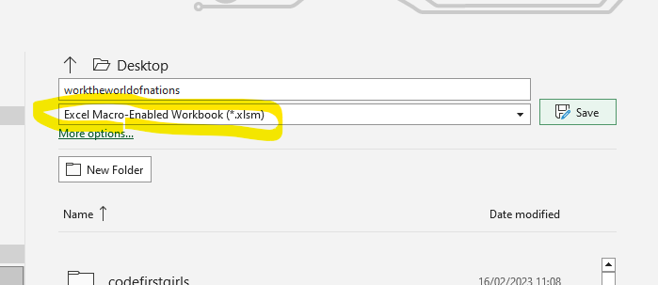

Then I press control + m , the shortcut chose for the current macros I have just recorder and comes up a message : A file name …aready exist, in this case I press yes and I replace it.
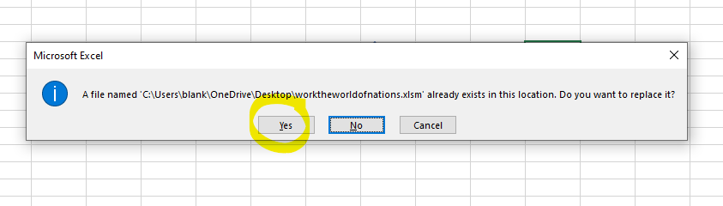

I want to see the macros I have just created, so I go to View > Macros.
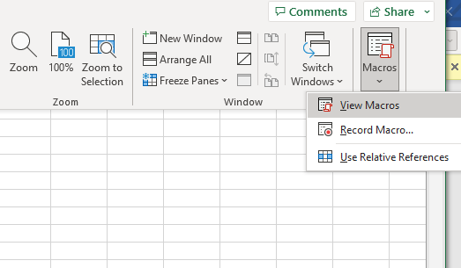

I press run macros , so to see the action I click on run and if it says the file name already exist, in this case I press no to replace it.
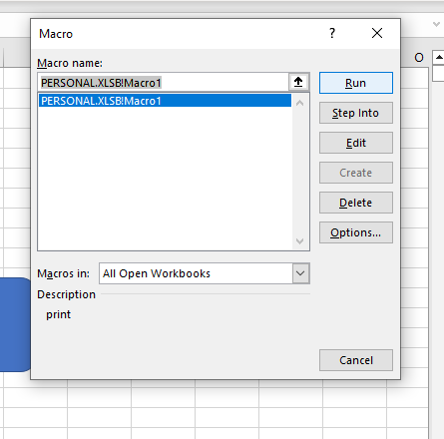
And in the next message I press to end the process.
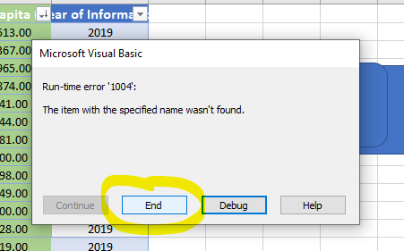
So after that, we can assign it to a sheet which we can link to a button.
In this case I go to insert a shape and I select a rectangle for my first button.
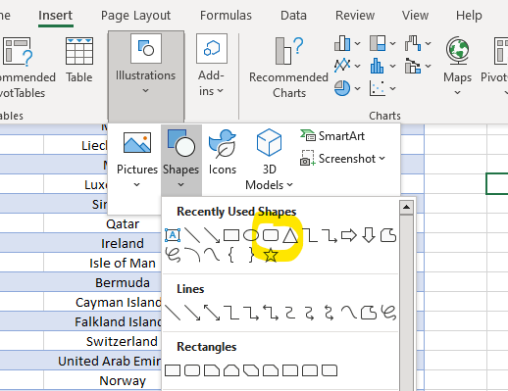

I click 2 times on the shape and I select assign macro1, I press ok. Then I assign the macros to my shape.

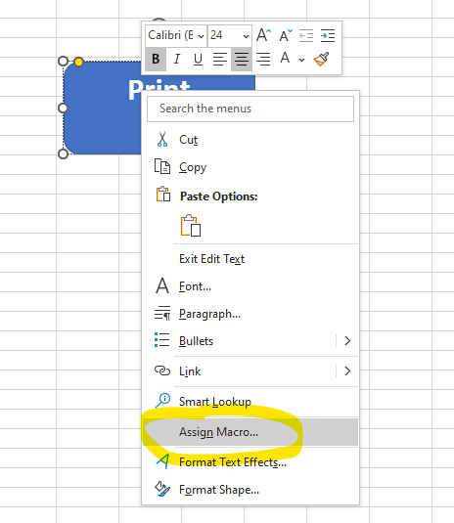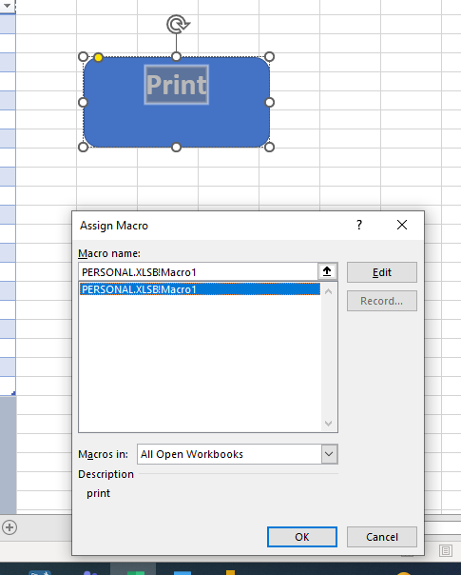

I continue the same process with the rest of the macros and buttons I have created:
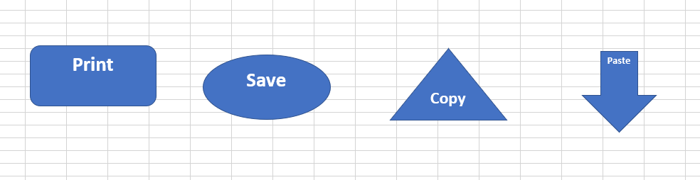

- Save your document as ‘Word Gross domestic product report 1’

Third Task Tableau

- Import data
- Set relationships:
I am using the tableau online version. I open tableau and first I do is open the worksheet The Wealth of nations.
The way to set the relationship is to click on the dropdown , so we look for a commun relationship, in this case we select country as a commun relationship between GDP and life expectancy, and the same for life expectancy and smartphones.
We open the excel sheet on tableau:

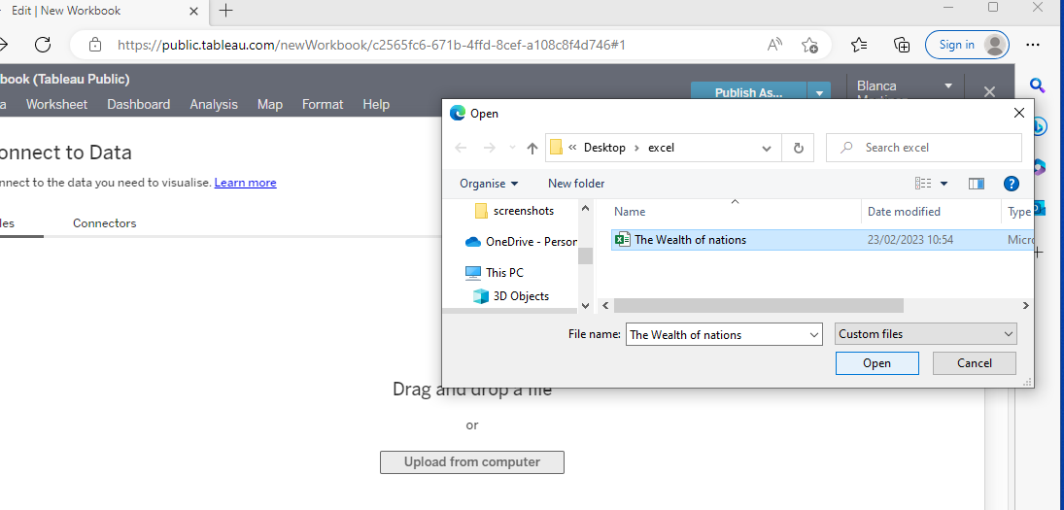

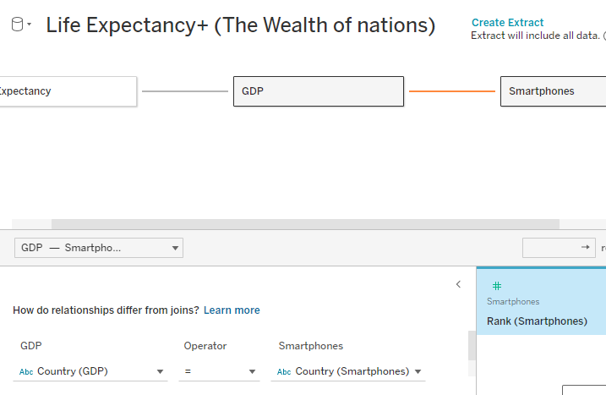
I make the relationship manually.

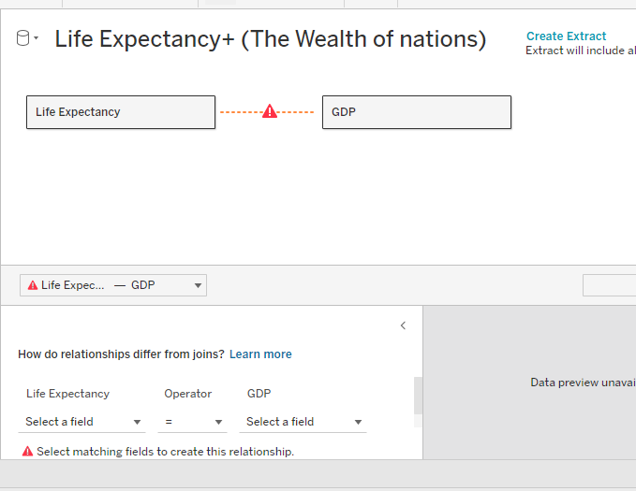

We also add country in both categories.

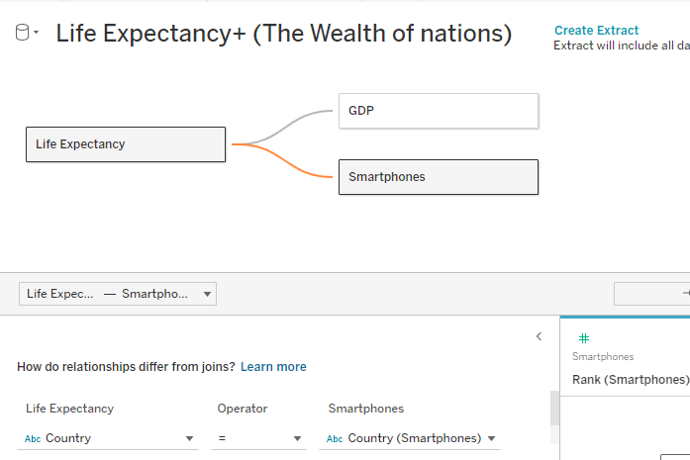

After set the relationships between life expectancy to GDP and Life expectancy to Smarthpones, I proceed to create the sheets.
I have created 4 sheets to represent the information of the Wealth of Nations.
1, First sheet: A limit of 20 countries with the highest rent per capita represented in the worldmap. I have added in the filter only the 20 first countries with the GPD higher.

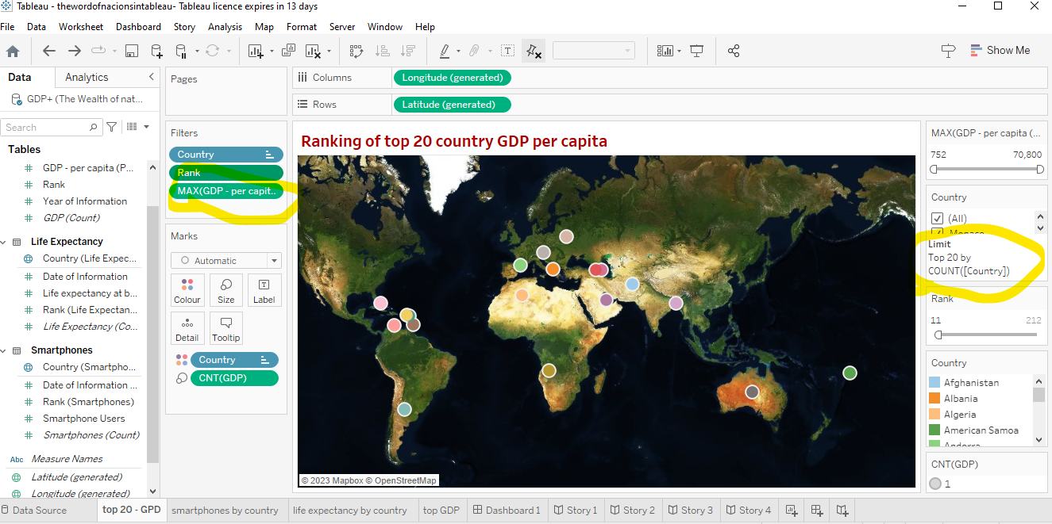

2. Second sheet: Life expectancy by country.
This sheet represents mainly the average of life expectancy by country. In the chart if we scroll down we can see the highest at the top being Hong Kong and Japan the countries on the top of the list with 85years old of life expectancy showing the lowest at the end of the list with 53 years old of Central African Republic.
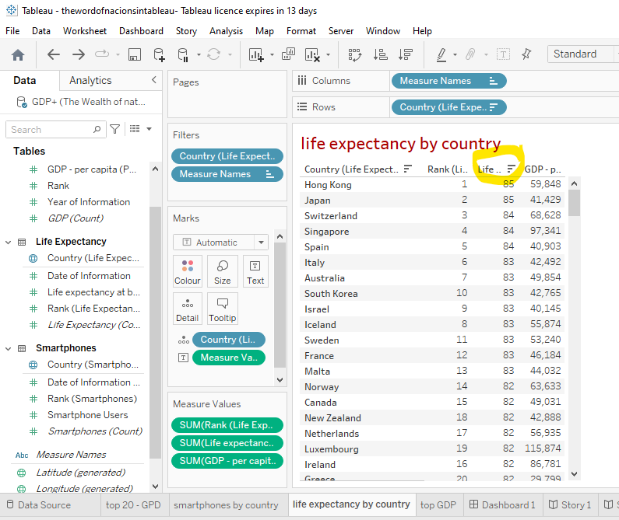

3. The third sheet: Top GDP country per capita
This sheet shows the top GDP per country showing the blue dark the highest countries per capita with Monaco leading the top of GDP country per capita.
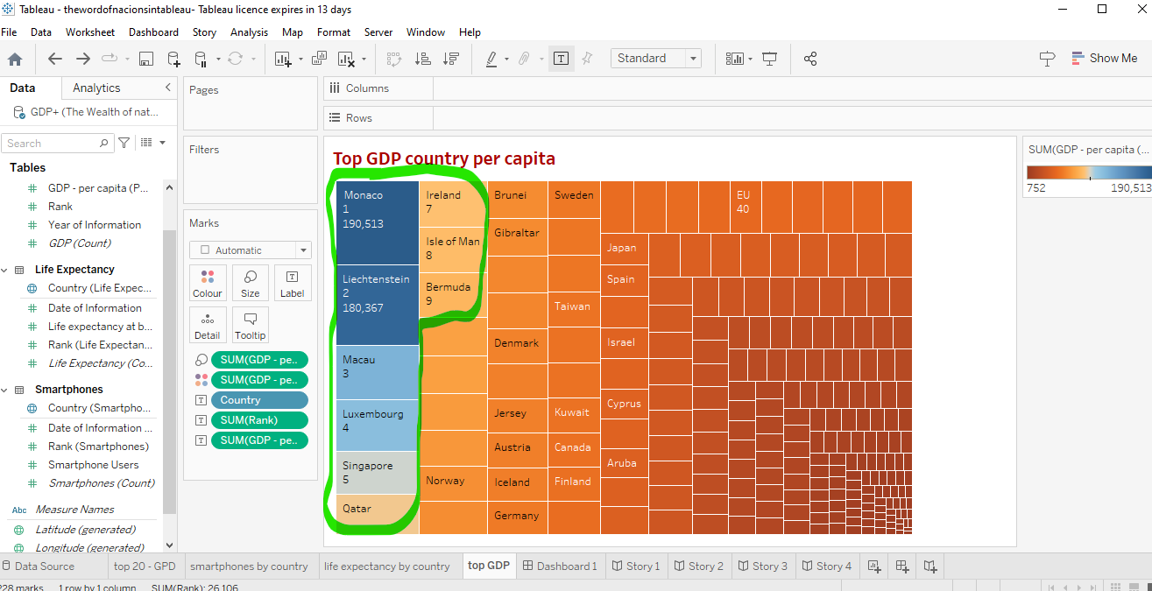
4. The fourth sheet: The smartphones by country showing China and India the countries with the higher number of smartphones in the world.

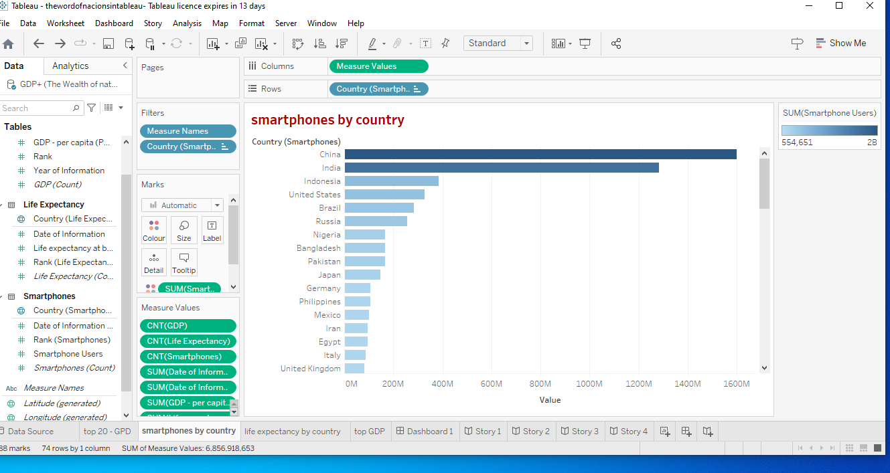

A reflective learning log

This assignment it is a summary about we have learnt so far so it is a good way to go over and revise what we have learnt. Starting from the first exercise, a good way to keep in mind the importance of work with good practice, the The computer Misuse Act 1990 and the DGPR The General Data Protection Regulation that a data technician should know.
I feel I have more confident now in how to represent data in excel and also in tableau. The exercise on tableau helped me out to keep in my mind the steps from connect the relationships until create a dashboard.
Areas for the development will be work with formulas on excel and on tableau, filtering, create groups and sets.
After doing this exercise, I can understand better the use of each tool and I can see that both, excel and tableau are good tools to analyze and visualize data.

